**Assignment 02- Fitting and Alignment-200148M-**[**GitHub**](https://github.com/CharithDombawala/Image_Processing/blob/main/Assignment_2/Ass2.ipynb)

**Question-01**

# Load the image

im = cv.imread('the_berry_farms_sunflower_field.jpeg', cv.IMREAD_REDUCED_COLOR_4)

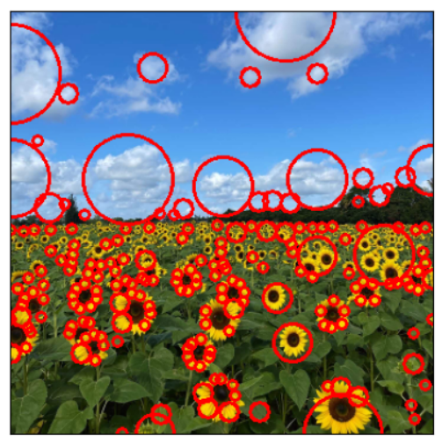# Apply Gaussian blur to reduce noise

blurred = cv.GaussianBlur(im, (**9**, **9**), **0.1**)

# Convert the image to grayscale

gray = cv.cvtColor(blurred, cv.COLOR_BGR2GRAY)

# Define parameters for blob detection

min_sigma = **3**

max_sigma = **30**

threshold = .**1**

# Detect blobs using Laplacian of Gaussians

blobs = blob_log(gray, min_sigma=min_sigma, max_sigma=max_sigma, threshold=threshold)

blobs[:, **2**] = blobs[:, **2**] * sqrt(**2**)

max_radius_index = np.argmax(blobs[:, **2**])

largest_circle_params = blobs[max_radius_index]

y, x, r = largest_circle_params

print(f"Radius (r): {r}")

print(f"Center (x, y): ({x}, {y})")

# Draw circles on the original color image

Figure

**for** blob **in** blobs:

y, x, r = blob # Blob format is (y, x, r)

cv.circle(im, (int(x), int(y)), int(r), (**0**, **0**, **255**), **2**)

**parameters of the largest circles.**

* Radius (r): 42.42640687
* Center (x, y): (234.0, 0.0)

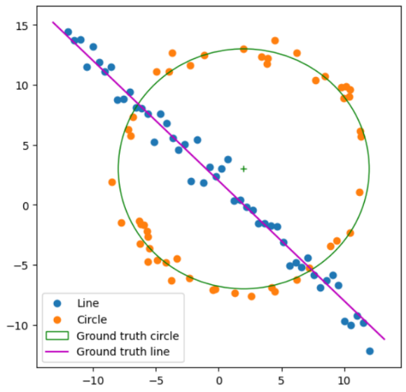**Question-02**

Figure 3 Line Estimation using RNASAC.

Figure 2 Noisy Point Set Generation

**def** **circle_equation**(points):

""" Return the center and radius of the circle from three points """

p1,p2,p3 = points[**0**], points[**1**], points[**2**]

temp = p2[**0**] * p2[**0**] + p2[**1**] * p2[**1**]

bc = (p1[**0**] * p1[**0**] + p1[**1**] * p1[**1**] - temp) / **2**

cd = (temp - p3[**0**] * p3[**0**] - p3[**1**] * p3[**1**]) / **2**

det = (p1[**0**] - p2[**0**]) * (p2[**1**] - p3[**1**]) - (p2[**0**] - p3[**0**]) * (p1[**1**] - p2[**1**])

# Center of circle

cx = (bc*(p2[**1**] - p3[**1**]) - cd*(p1[**1**] - p2[**1**])) / det

cy = ((p1[**0**] - p2[**0**]) * cd - (p2[**0**] - p3[**0**]) * bc) / det

radius = np.sqrt((cx - p1[**0**])\*\***2** + (cy - p1[**1**])\*\***2**)

**return** ((cx, cy), radius)

**def** **get_inliers**(data_list, center, r):

""" Returns the list of inliers to a model of a circle from a set of points. The threshold value is taken as 1/5th of the radius """

inliers = []

thresh = r//**3**

**for** i **in** range(len(data_list)):

error = np.sqrt((data_list[i][**0**]-center[**0**])\*\***2** + (data_list[i][**1**]-center[**1**])\*\***2**) - r

**if** error < thresh:

inliers.append(data_list[i])

**return** np.array(inliers)

**def** **random_sample**(data_list):

""" Returns a list of 3 random samples from a given list """

sample_list = []

random.seed(**0**)

rand_nums = random.sample(range(**1**, len(data_list)), **3**)

**for** i **in** rand_nums:

sample_list.append(data_list[i])

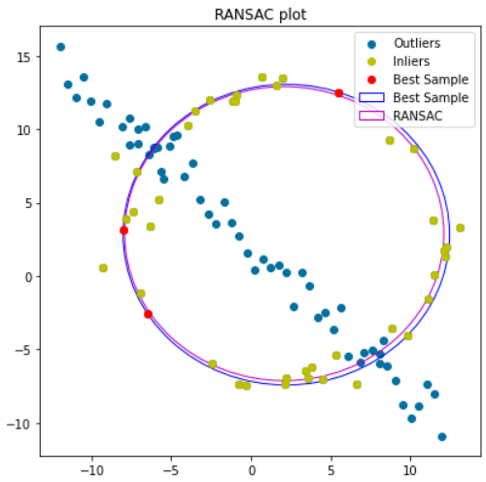 **return** np.array(sample_list)

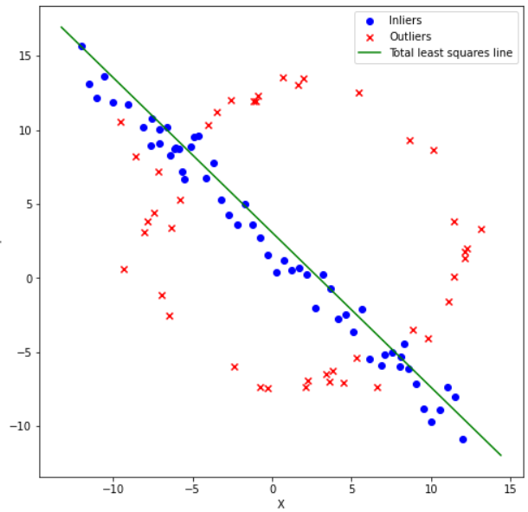

**Part(d) -** Fitting a circle is more complex than fitting a line, as it involves more parameters. If we try to fit a circle first, it might end up looking like a line with an extremely large radius, resulting in an incorrect fit.

**Question-03**

**for** i **in** range(**2**):

im = cv.imread(ims[i])

cv.imshow("Wadham College",im)

corners = []

cv.setMouseCallback("Wadham College", mouse_click), cv.waitKey(**0**), cv.destroyAllWindows()

h, w = np.shape(im)[**0**], np.shape(im)[**1**]

zero_matrix = np.array([[**0**], [**0**], [**0**]])

x1, y1, x2, y2, x3, y3, x4, y4 = corners[**0**][**0**], corners[**0**][**1**], corners[**1**][**0**], corners[**1**][**1**], corners[**2**][**0**], corners[**2**][**1**], corners[**3**][**0**], corners[**3**][**1**]

flag_im = cv.imread("Flag_of_the_United_Kingdom.png")

fh, fw , ch= flag_im.shape

f1, f2, f3, f4 = np.array([[**0**, **0**, **1**]]), np.array([[fw-**1**, **0**, **1**]]), np.array([[fw-**1**, fh-**1**, **1**]]), np.array([[**0**, fh-**1**, **1**]])

matrix_A = np.concatenate((np.concatenate((zero_matrix.T,f1, -y1*f1), axis = **1**), np.concatenate((f1, zero_matrix.T, -x1*f1), axis = **1**),

np.concatenate((zero_matrix.T,f2, -y2*f2), axis = **1**), np.concatenate((f2, zero_matrix.T, -x2*f2), axis = **1**),

np.concatenate((zero_matrix.T,f3, -y3*f3), axis = **1**), np.concatenate((f3, zero_matrix.T, -x3*f3), axis = **1**),

np.concatenate((zero_matrix.T,f4, -y4*f4), axis = **1**), np.concatenate((f4, zero_matrix.T, -x4*f4), axis = **1**)), axis = **0**, dtype=np.float64)

W, v = np.linalg.eig(((matrix_A.T)**@matrix_A**))

temph= v[:,np.argmin(W)]

H = temph.reshape((**3**,**3**))

transformed_flag = cv.warpPerspective(flag_im, H, (w, h))

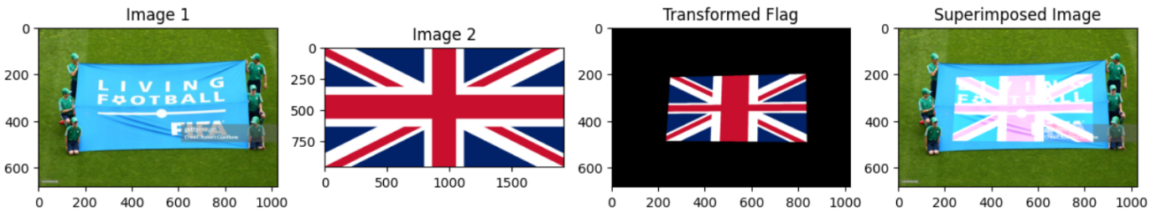 final = cv.add(transformed_flag, im)

**Question-04**

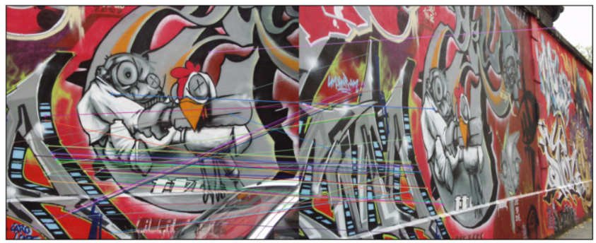

Figure **Question 4(a)**

**Part(b)**

**def** **homography**(pts1, pts2):

mean1, mean2 = np.mean(pts1, axis=**0**), np.mean(pts2, axis=**0**)

s1, s2 = len(pts1)*np.sqrt(**2**)/np.sum(np.sqrt(np.sum((pts1-mean1)\*\***2**, axis=**1**))), len(pts1)*np.sqrt(**2**)/np.sum(np.sqrt(np.sum((pts2-mean2)\*\***2**, axis=**1**)))

tx1, ty1, tx2, ty2 = -s1*mean1[**0**], -s1*mean1[**1**], -s2*mean2[**0**], -s2*mean2[**1**]

T1, T2 = np.array(((s1, **0**, tx1), (**0**, s1, ty1), (**0**, **0**, **1**))), np.array(((s2, **0**, tx2), (**0**, s2, ty2), (**0**, **0**, **1**)))

A = []

**for** i **in** range(len(pts1)):

X11, X21 = T1 * np.concatenate((pts1[i], [**1**])).reshape(**3**, **1**), T2 * np.concatenate((pts2[i], [**1**])).reshape(**3**, **1**)

A.append((-X11[**0**][**0**], -X11[**1**][**0**], -**1**, **0**, **0**, **0**, X21[**0**][**0**]*X11[**0**][**0**], X21[**0**][**0**]*X11[**1**][**0**], X21[**0**][**0**]))

A.append((**0**, **0**, **0**, -X11[**0**][**0**], -X11[**1**][**0**], -**1**, X21[**1**][**0**]*X11[**0**][**0**], X21[**1**][**0**]*X11[**1**][**0**], X21[**1**][**0**]))

A = np.array(A)

U, S, V = np.linalg.svd(A, full_matrices=**True**)

h = np.reshape(V[-**1**], (**3**, **3**))

H = linalg.inv(T2) * h * T1

H = (**1** / H.item(**8**)) * H

**return** H

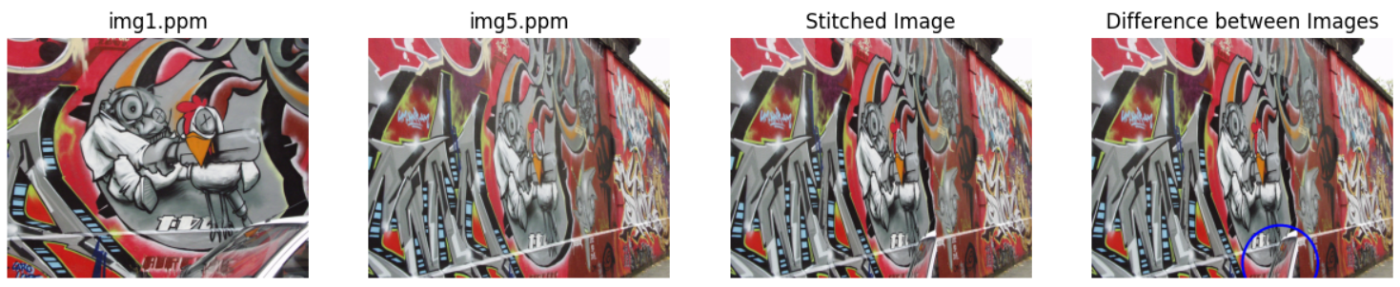

Figure Computed homography

**Part(c)**